(Research Article/Literature Review)
Please Write the Article Title, Capitalizing the First Letter of Each Word
First Author ¹, Second Author ^{2,*}, Third Author ¹
¹ First and Third Author's Affiliation, Address, City Name and Postal Code, Country
² Second Author's Affiliation, Address, City Name and Postal Code, Country

ARTICLE INFORMATION |  | ABSTRACT
Submitted : dd month yyyy  Accepted : 00 Maret 0000  Published : 00 April 0000 |  | The abstract is a summary of the article's content that contains the sequence of the problem, method, proposed solution, and conclusion. The abstract is written in 1 paragraph, with 1.5 line spacing, and consists of 150-200 words. The abstract is a summary of the article's content that contains the sequence of the problem, method, proposed solution, and conclusion. The abstract is written in 1 paragraph, with 1.5 line spacing, and consists of 150-200 words. The abstract is a summary of the article's content that contains the sequence of the problem, method, proposed solution, and conclusion. The abstract is written in 1 paragraph, with 1.5 line spacing, and consists of 150-200 words. The abstract is a summary of the article's content that contains the sequence of the problem, method, proposed solution, and conclusion. The abstract is written in 1 paragraph, with 1.5 line spacing, and consists of 150-200 words. The abstract is a summary of the article's content that contains the sequence of the problem, method, proposed solution, and conclusion. The abstract is written in 1 paragraph, with 1.5 line spacing, and consists of 150-200 words.
KEYWORDS
"Five words maximum"
"Written in a single sentence, with each keyword separated by a comma (,)."
"Sort alphabetically"
CORRESPONDENCE
*E-mail: author@affiliation.xx.xx

INTRODUCTION
This article serves as a template for writing in JURNAL SURYA TEKNIKA using MS-Word. Articles may be written in either English or Indonesian. Use Times New Roman font with a size of 11 pt. The article length ranges from 10 to 15 pages in A4 paper format. The title is written in Times New Roman 16 pt, justified alignment, followed by the author's name in Times New Roman 12 pt, and the author's institution and corresponding email address in Times New Roman 9 pt. Each new paragraph begins with an indented first line. All articles are written in two columns; before writing, please adjust your article's margins to match the margins of this template by referring to the page setup of the template we have provided.

The article is written with a structure consisting of Introduction, Research Methodology, Results and Discussion, Conclusion, References, and Appendices (if necessary). The chapter titles are formatted according to this template by selecting the available style, namely Heading 1.

Authors must ensure that their work does not contain any elements of plagiarism. Articles that have already been published as conference proceedings will not be accepted for publication in JURNAL SURYA TEKNIKA.
Use this template by utilizing the available styles or by copying and pasting to facilitate the process of writing your article.

METHOD
Explain the stages undertaken in the research, concept development, or case resolution. Mathematical equations must be numbered sequentially, starting with (1) through to the end of the paper, including the appendix. This numbering must be enclosed in opening and closing parentheses and aligned to the right.
$V_{s}= \frac{π}{4}D^{2}S$ (1)
The nomenclature of mathematical equations is written in a separate section after the References.

Second-Level Subsection
Second-level subsections are written in boldface italics using uppercase and lowercase letters. Subsections are aligned to the left.

Third-Level Subsection
Third-level subsections follow the style of the second-level subsections. Avoid using subsections beyond three levels.

Writing References
The detailed method for writing references can be seen in the References section. Citations follow the IEEE style. References within the text are made by writing the reference number in brackets [1]. Some examples of citation formats include:
As shown by Brown [4], [5]; As mentioned previously [2], [4]-[7], [9];
JURNAL SURYA TEKNIKA strongly recommends using reference management software such as Mendeley or EndNote.

RESULT AND DISCUSSION

Table
Table captions are placed above the table. Captions are written in lowercase except for the first character of each sentence. All tables must be numbered sequentially. Table titles are center-aligned on the page, and the word "Table" is written in bold.

Table 1.
First Table Title
Diesel Oil (%) | Coconut Oil (%) | Candlenut Oil (%) | Consumption (cc/minute)
90 % | 5 % | 5 % | 1,56
85 % | 10 % | 5 % | 1,47
85 % | 5 % | 10 % | 1,45

Figure
Captions must be provided below each figure. All figures must be numbered sequentially. Figures are placed in the center of the page (center aligned). The method for presenting figures can be seen in Figure 1. Figure captions are placed at the bottom of the figure.

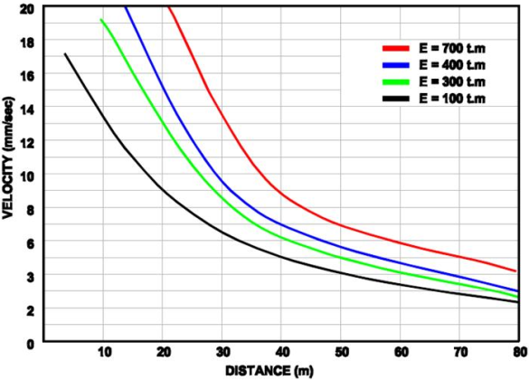
Figure 1. Example of Caption Writing for Figures

CONCLUSIONS
The conclusion contains a brief and concise statement of the research findings. It also includes suggestions regarding the prospects for development and application of the research results. The conclusion is written in paragraph format rather than in point form.

This template is created to ensure consistency in the format of articles published by JURNAL SURYA TEKNIKA. The authors' cooperation and willingness to follow the writing guidelines are greatly appreciated.

ACKNOWLEDGEMENT
If applicable, please write it in this section. The acknowledgement only relates to the research funding source by stating the contract number.

REFERENCES
Journal
- J. K. Author, “Name of paper,” Abbrev. Title of Periodical, vol. x, no. x, pp. xxx-xxx, Abbrev. Month, year.
Book
- J. K. Author, “Title of chapter in the book,” in Title of His Published Book, xth ed. City of Publisher, Country if not USA: Abbrev. of Publisher, year, ch. x, sec. x, pp. xxx–xxx.
Report
- J. K. Author, “Title of report,” Abbrev. Name of Co., City of Co., Abbrev. State, Rep. xxx, year.
Handbook
- Name of Manual/Handbook, x ed., Abbrev. Name of Co., City of Co., Abbrev. State, year, pp. xxx-xxx.
Procedings
- J. K. Author, “Title of paper,” in Unabbreviated Name of Conf., City of Conf., Abbrev. State (if given), year, pp. xxx-xxx.
Paper presented at a Conference
- J. K. Author, “Title of paper,” presented at the Unabbrev. Name of Conf., City of Conf., Abbrev. State, year.
Patent
- J. K. Author, “Title of patent,” U.S. Patent x xxx xxx, Abbrev. Month, day, year.
Thesis and Dissertation
- J. K. Author, “Title of thesis,” M.S. thesis, Abbrev. Dept., Abbrev. Univ., City of Univ., Abbrev. State, year.
- J. K. Author, “Title of dissertation,” Ph.D. dissertation, Abbrev. Dept., Abbrev. Univ., City of Univ., Abbrev. State, year.

NOMENCLATURE
The nomenclature, along with the meaning of all mathematical equations or other nomenclature used in the article, is written in this section.

ρ the meaning of ρ
E the meaning of variable E
J_{c} the meaning of variable J_{c}

